1. BANK LOAN REPORT | SUMMARY

KPI’S:

Total Loan Applications

select count(id) AS Total_Applications from bank_loan_data

MTD Total Loan Applications

select count(id) AS MTD_Total_Applications from bank_loan_data

where MONTH(issue_date) = 12 AND YEAR(issue_date)=2021

PMTD Loan Applications

select count(id) AS PMTD_Total_Applications from bank_loan_data

where MONTH(issue_date) = 11 AND YEAR(issue_date)=2021

Total Funded Amount

SELECT SUM(loan_amount) AS Total_Funded_Amount FROM bank_loan_data

MTD Total Funded Amount

SELECT SUM(loan_amount) AS MTD_Total_Funded_Amount FROM bank_loan_data

WHERE MONTH(issue_date) = 12 AND YEAR(issue_date) = 2021

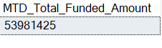

PMTD Total Funded Amount

SELECT SUM(loan_amount) AS PMTD_Total_Funded_Amount FROM bank_loan_data

WHERE MONTH(issue_date) = 11 AND YEAR(issue_date) = 2021

Total Amount Received

select SUM(total_payment)AS Total_Amount_received from bank_loan_data

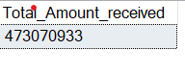

MTD Total Amount Received

select SUM(total_payment) AS MTD_Total_Amount_Received from bank_loan_data

where MONTH(issue_date) = 12 AND YEAR(issue_date) = 2021



PMTD Total Amount Received

select SUM(total_payment) AS PMTD_Total_Amount_Received from bank_loan_data

where MONTH(issue_date) = 11 AND YEAR(issue_date) = 2021



Average Interest Rate

select ROUND(AVG(int_rate),4)*100 AS Avg_Interest_Rate from bank_loan_data

MTD Average Interest Rate

select ROUND(AVG(int_rate),4)*100 AS MTD_Avg_Interest_Rate from bank_loan_data

where MONTH(issue_date) = 12 AND YEAR(issue_date) = 2021

PMTD Average Interest Rate

select ROUND(AVG(int_rate),4)*100 AS PMTD_Avg_Interest_Rate from bank_loan_data

where MONTH(issue_date) = 11 AND YEAR(issue_date) = 2021

Average DTI

select ROUND(AVG(dti),4)*100 AS Avg_DTI from bank_loan_data

MTD Average DTI

select ROUND(AVG(dti),4)*100 AS MTD_Avg_DTI from bank_loan_data

where MONTH(issue_date) = 12 AND YEAR(issue_date) = 2021

PMTD Average DTI

select ROUND(AVG(dti),4)*100 AS PMTD_Avg_DTI from bank_loan_data

where MONTH(issue_date) = 11 AND YEAR(issue_date) = 2021

Good Loan Percentage

select

(count(CASE WHEN loan_status = 'Fully Paid' OR loan_status ='Current' THEN id END)*100)

/

COUNT(id) AS Good_loan_percentage from bank_loan_data

Good Loan Applications

select COUNT(id) AS Good_loan_Applications FROM bank_loan_data

where loan_status = 'Fully Paid' OR loan_status='Current'

Good Loan Funded Amount

select SUM(loan_amount) AS Good_loan_Funded_Amount FROM bank_loan_data

where loan_status = 'Fully Paid' OR loan_status='Current'

Good Loan Received Amount

select SUM(total_payment) AS Good_loan_Received_Amount FROM bank_loan_data

where loan_status = 'Fully Paid' OR loan_status='Current'

BAD LOAN DATA:

Bad Loan Application

select count(id) AS Bad_Loan_Application from bank_loan_data

where loan_status='Charged Off'

Bad Loan Percentage

select

(count(CASE WHEN loan_status = 'Charged off' THEN id END)*100.0)

/

COUNT(id) AS Bad_loan_percentage from bank_loan_data

Bad Loan Funded Amount

select SUM(loan_amount) AS Bad_loan_Funded_Amount FROM bank_loan_data

where loan_status = 'Charged Off'

Bad Loan Received Amount:

select SUM(total_payment) AS Bad_loan_Received_Amount FROM bank_loan_data

where loan_status = 'Charged Off'

LOAN STATUS:

select

loan_status,

count(id) AS Total_Loan_Applocations,

Sum(total_payment) AS Total_Payment_Received,

Sum(loan_amount) AS Total_Funded_Amount,

AVG(int_rate * 100) AS Interest_Rate,

AVG(dti *100) AS DTI

FROM

bank_loan_data

GROUP BY

loan_status

select

loan_status,

SUM(total_payment) AS MTD_Total_Amount_Received,

SUM(loan_amount) AS MTD_Total_Funded_Amount

FROM bank_loan_data

where MONTH(issue_date) = 12

GROUP BY loan_status

MONTH

SELECT

MONTH(issue_date) AS Month_Number,

DATENAME(MONTH, issue_date) AS Month_Name,

COUNT(id) AS Total_Loan_Applications,

SUM(loan_amount) AS Total_Funded_Amount,

SUM(total_payment) AS Total_Received_Amount

FROM bank_loan_data

GROUP BY MONTH(issue_date),DATENAME(MONTH, issue_date)

ORDER BY MONTH(issue_date)

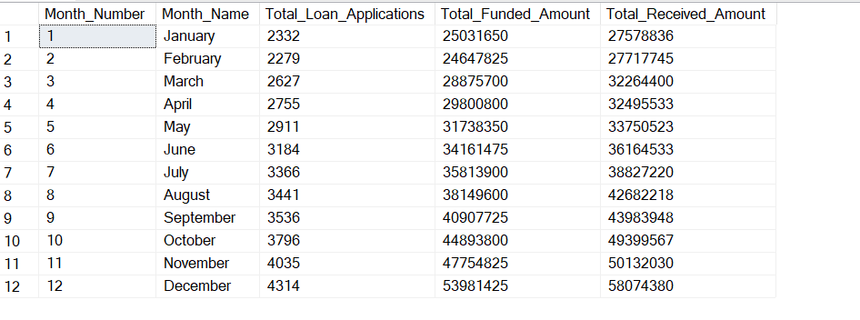

Address State:

SELECT

address_state,

COUNT(id) AS Total_Loan_Applications,

SUM(loan_amount) AS Total_Funded_Amount,

SUM(total_payment) AS Total_Received_Amount

FROM bank_loan_data

GROUP BY address_state

ORDER BY COUNT(id) DESC

TERM:

SELECT

term,

COUNT(id) AS Total_Loan_Applications,

SUM(loan_amount) AS Total_Funded_Amount,

SUM(total_payment) AS Total_Received_Amount

FROM bank_loan_data

GROUP BY term

ORDER BY term

EMP_LENGTH

SELECT

emp_length,

COUNT(id) AS Total_Loan_Applications,

SUM(loan_amount) AS Total_Funded_Amount,

SUM(total_payment) AS Total_Received_Amount

FROM bank_loan_data

GROUP BY emp_length

ORDER BY COUNT(id) DESC

PURPOSE:

SELECT

purpose,

COUNT(id) AS Total_Loan_Applications,

SUM(loan_amount) AS Total_Funded_Amount,

SUM(total_payment) AS Total_Received_Amount

FROM bank_loan_data

GROUP BY purpose

ORDER BY COUNT(id) DESC

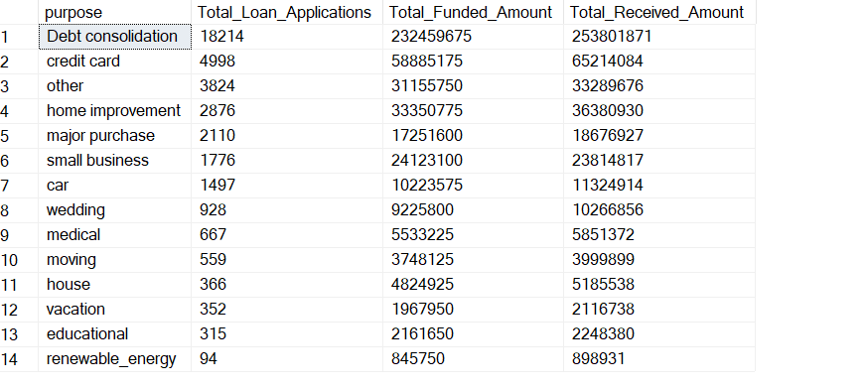

Home-Ownership

SELECT

home_ownership,

COUNT(id) AS Total_Loan_Applications,

SUM(loan_amount) AS Total_Funded_Amount,

SUM(total_payment) AS Total_Received_Amount

FROM bank_loan_data

GROUP BY home_ownership

ORDER BY COUNT(id) DESC

